**Phase-3**

**3.1 :** Find the correlation between price movements of different Spot Cryptocurrencies having same currency pair, for example, use all Cryptocurrency and USD pairs first. Plot the heatmap for showing correlation values. Calculate correlation month-wise or week-wise so that we can find pattern, if any, related to different cryptocurrencies movements and match it with any important news event occurred during that period. Also, use data of cryptocurrencies from single exchange at a time, it will help us to remove the noise due to price variation among the exchanges.

A typical heatmap with correlation values may look like:

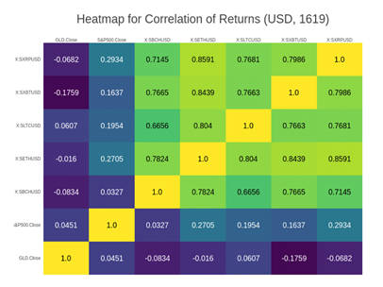

**3.2 :** Similar to price correlation find out in 3.1, find the correlation between ‘traded volumes’ of different Spot Cryptocurrencies and plot the related heatmap. As volume data is mentioned in Spot-2 files (Type B) only so ignore this plot for Spot-1 files.

**3.3 :** Compare the traded volume of Bitcoin Spot and Futures. Calculate correlation month-wise or week-wise so that we can find pattern, if any, and match it with any important news event occurred during that period. Use Spot-2 file (Type B) for volume data of Bitcoin Spot (XBT/USD for all available exchanges) and use both Futures-1 (CBOE exchange) and Futures-2 (CME exchange) files for Bitcoin Futures (XBT/USD and BTC/USD for all available expiry dates).

A typical plot may look like as below:

This plot represents 2018 monthly-volume data comparison. For each month, CBOE and CME traded volume have been plotted on same vertical bar representing Futures’ traded volume and traded volume from exchanges like Coinbase (CNB), Kraken (KKN) have been plotted on other vertical bar representing Spot’s traded volume.

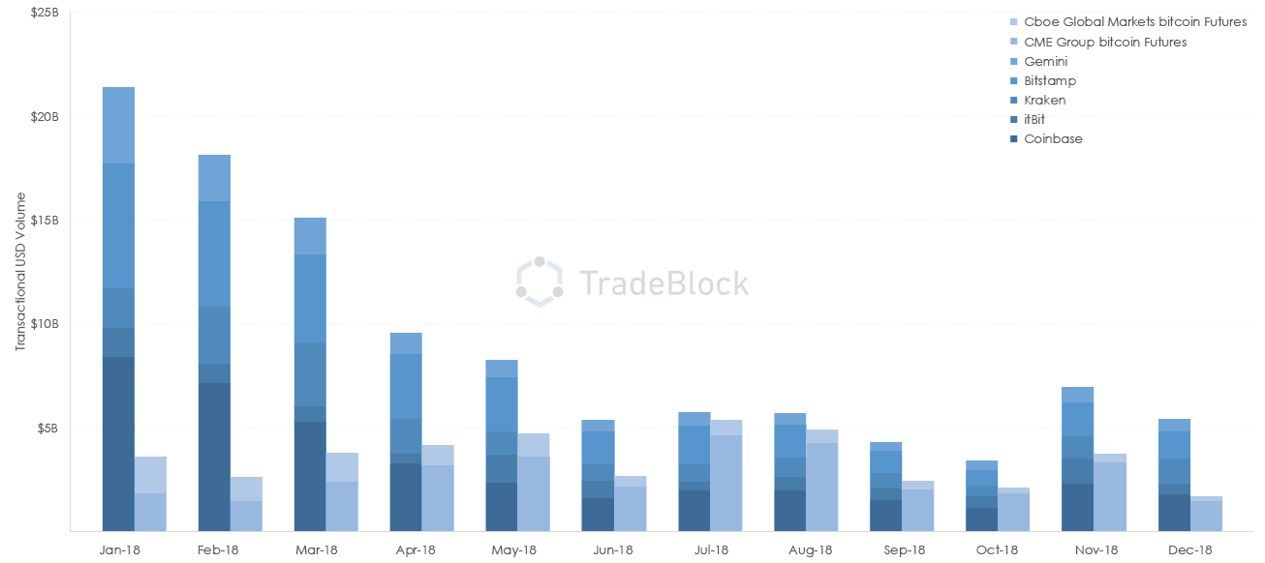

**3.4:** Through this program plot volume – traded volume or bid volume or ask volume – for any type of file available for a particular day for a particular instrument (in Futures files only Bitcoin matters) chosen by user.

**3.5:** Plot average “monthly” standard deviation in trade prices of Spot cryptocurrencies like Bitcoin, Ethereum, Litecoin.

**3.6:** Plot three prices mentioned below in a single plot for the given 4-month period (Jan-Apr’19):

1) Bitcoin Spot price [with option of selecting Spot-1 (Type A) or Spot-2 (Type B) file and selecting one exchange out of available exchanges] 🡪 take daily close price for plotting.

2) Bitcoin Futures price [with option of selecting Futures-1 (CBOE) or Futures-2 (CME) file and selecting a Bitcoin Futures of a particular expiry date] 🡪 take daily close price for plotting, and

3) Theoretical Price of Bitcoin Futures calculated using below formula and the input provided by user (like expiry date).

The theoretical formula for calculating the futures price from the spot price is as follows:

Crypto-currency Futures Price = Crypto-currency Spot price * [1+ rf*(x/365)]

Where rf = risk-free rate on annual-basis = 0.02 (this value can be assumed for ‘rf’)

And x = number of days to expiry

Here in the plot limiting factor is the expiry date of the Bitcoin Futures. The graph needs to be plotted till the day on which Futures instrument chosen by the user expire.

**References:**

* <https://www.theblockcrypto.com/2019/01/04/analysis-correlation-between-cryptocurrency-prices-sharply-increased-in-2018/>
* <https://cryptopotato.com/bitcoin-futures-vs-spot-trading-a-new-report-reveals-the-inverse-correlation-during-2018-bear-market/>
* <https://www.coindesk.com/public-perceptions-of-the-bitcoin-spot-market-are-wrong-says-bitwise>
* <https://www.sciencedirect.com/science/article/abs/pii/S1544612319304714>